SOP 408: MEDICAL CASE REPORTS

BACKGROUND

A clinical case report is usually limited to an educational activity involving the presentation or publication of the clinical course and/or medical treatment of an interesting clinical case, and generally done by retrospective review of the medical record.

SCOPE

This policy provides guidance about the regulatory requirements associated with the presentation or publication of case reports.

PROCEDURES

Case Reports and RIRC Review

Case reports (with three or fewer patients) generally do not meet the federal definition of human subjects research, as they are not a systematic investigation.¹⁻⁶ Therefore, RIRC approval is not required.

If activity of the case is done with research intent (forming a hypothesis or drawing conclusions/findings outside of the case(s), or there are plans to use/call a case report research or to use for a research requirement, it may require RIRC approval.

Case series (four or more patients) do meet the federal definition of human subjects research. Therefore, RIRC approval is required.

Case Reports and Informed Consent

While case reports can provide valuable and detailed information of new or rare disease of an individual, information reported can identify a patient. Information in a medical record is considered the patient’s and has the A written informed consent is highly recommended. Some journals may require obtaining informed consent.

The signed informed consent should be uploaded into the patient’s CareLink record.

Case Reports and HIPAA Requirements

Although case reports do not require RIRC review, they must still comply with the HIPAA Privacy Rule requirements about Protected Health Information (PHI). Authors should follow one of the following three paths prior to working on the case study.

De-identify: Authors who fully de-identify the case report do not need to obtain further authorization.
        - Remove all 18 identifiers specified in the Privacy Rule (Appendix 1).⁷
        - Ensure that no photo, image or illustration can lead to identification
          - Imaging room manager must remove embedded PHI
        - Ensure case described is not so unique as to be identifiable either through a “unique characteristic” or in combination with other information if someone looked at public sources (e.g. media accounts)
    - Obtain HIPAA Authorization: Authors who cannot completely de-identify the case report should obtain a signed HIPAA compliant authorization form (Appendix 2 or download from intranet here) from the patient or legally authorized representative as appropriate (e.g., patient deceased).
        - This authorization form does not need to be submitted to the RIRC but should be uploaded into the patients CareLink record (author should ask manager, director or medical director if help is needed).
    - Contact QMC Privacy Officer: Authors who cannot do option i. or ii. above should contact the QMC Privacy Officer (PrivacyOfficer@queens.org) for guidance
- Publication Requirements
  - Authors who are asked by a journal or other entity to provide documentation that the case report was approved by the RIRC or did not require RIRC review may present this Policy as evidence that case reports do not require RIRC approval. Some journals may require that the institution provide written attestation that the authorization of the subject has been obtained prior to publication of the case report. To obtain this attestation, please submit your protocol/proposal to RIRC at rirc@queens.org who will issue a formal letter.

Appendix 1. Definition of De-Identified Data

Identifiers That Must Be Removed to Make Health Information De-Identified
De-identified data are data that contain none of the 18 HIPAA identifiers. If all of the 18 identifiers are removed, the information is no longer (1) Individually identifiable, (2) PHI, and (3) subject to HIPAA's requirements.
- Names
- Dates, except year
- Telephone numbers
- Geographic data
- FAX numbers
- Social Security numbers
- Email addresses
- Medical record numbers
- Account numbers
- Health plan beneficiary numbers
- Certificate/license numbers
- Vehicle identifiers and serial numbers including license plates
- Web URLs
- Device identifiers and serial numbers
- Internet protocol addresses
- Full face photos and comparable images
- Biometric identifiers (i.e., retinal scan, fingerprints)
- Any unique identifying number or code

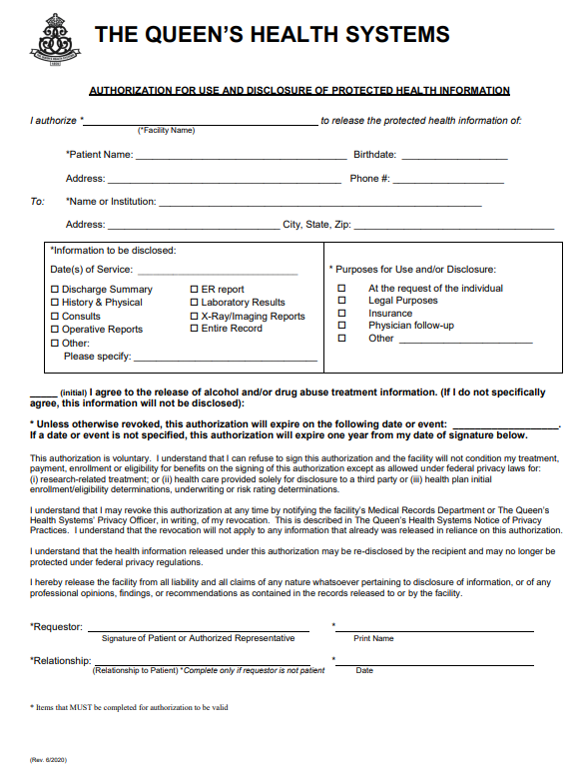
Appendix 2. Authorization for Use and Disclosure of Protected Health Information

