Human Ethics’ User Profile

1. **Upon logging in, you will be taken to the My Tasks webpage**

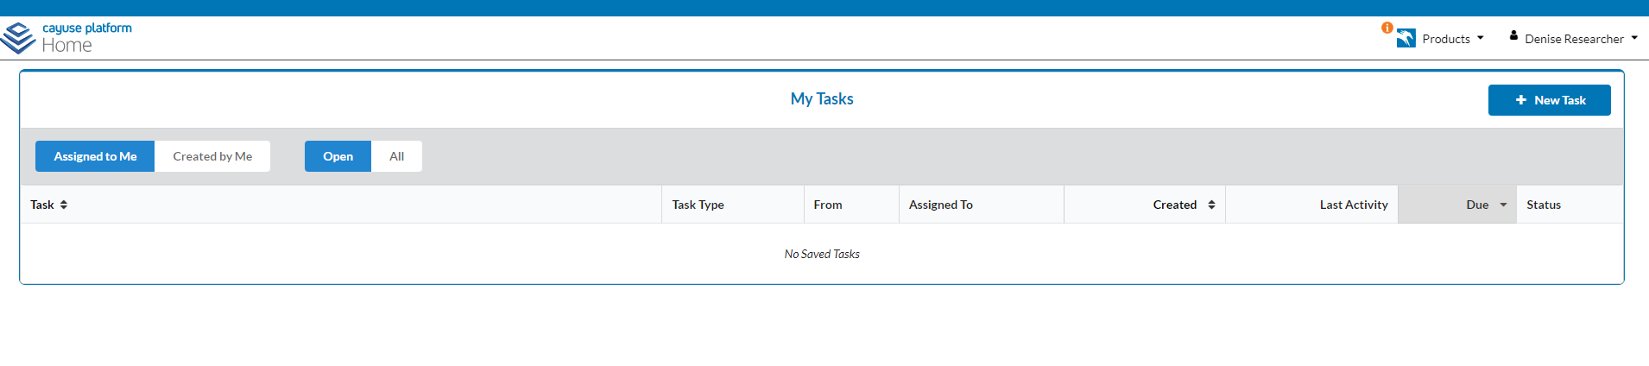

1. **Click on the top right corner. A dropdown menu will appear.**

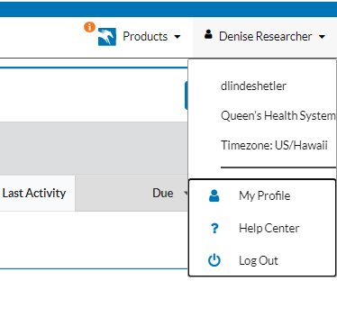

1. **Click on My Profile**
2. **You will be taken to your profile page under the current account. All fields populated with gray text are based on information you had provided when you requested a new user account.**

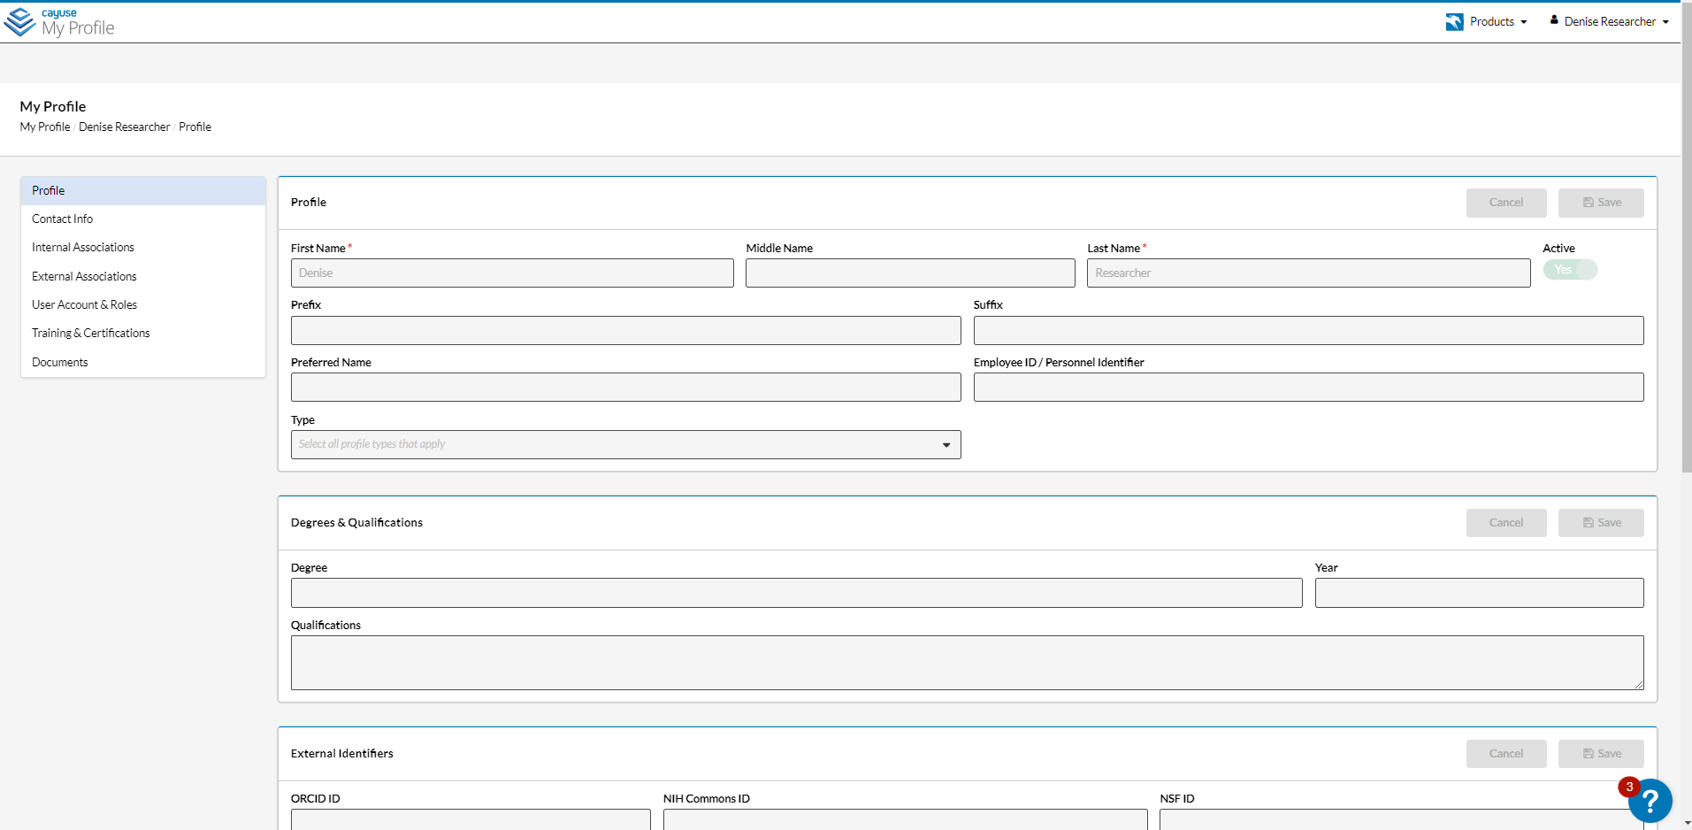

1. **To the left of the page, you will see several tabs:**

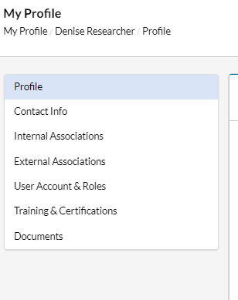

1. **Click on Training & Certifications. All CITI training completed under QMC will be displayed here.**

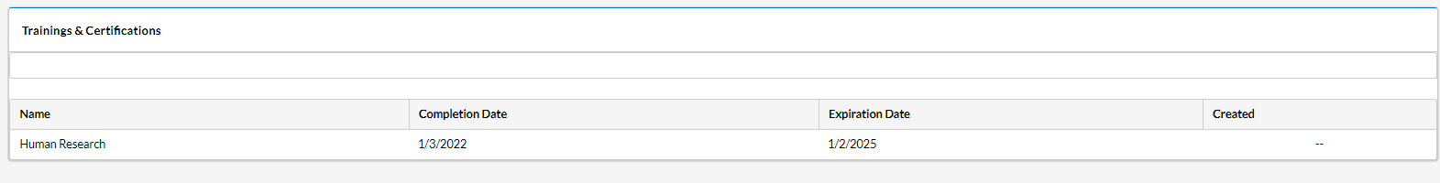

1. **Click on Documents. If you are a new user, your list should be blank:**

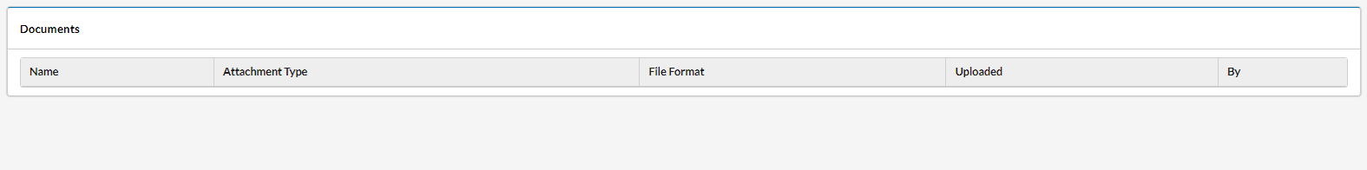

1. **When submitting your first initial submission through HE, you will need to attach relevant credentials and training documents. The IRB office will upload these documents to your profile during their review so that subsequent submissions of new studies will not require you to include these documents.**

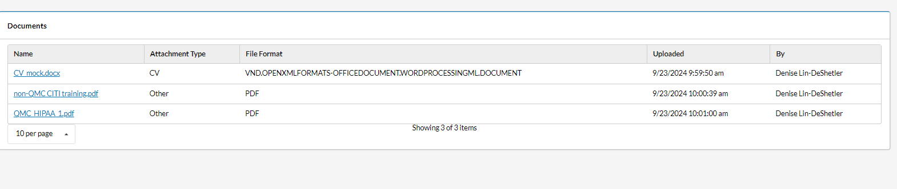

1. **Hyperlinks allow you to download and view what was uploaded to your profile.**
2. **Be mindful of expiration dates:**
   1. **Under Training & Certificates, the CITI training will automatically display the expiration date. However, the platform does not send our notifications to renew your CITI training**
   2. **Under Documents, files uploaded will not display expiration dates; only uploaded dates. Please routinely check to make sure your CV and training documents are up-to-date:**
      1. **Rule-of-Thumb:**
         1. **CVs/resume: every 2 years**
         2. **CITI human subjects research training: every 3 years**
         3. **QMC HIPAA training: no expiration, but recommend reviewing every year**